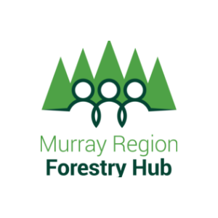

The Murray Region Forestry Hub has welcomed the news of an additional $8.9 million of Australian Government funding over 3 years for the original 9 Regional Forestry Hubs that was recently announced by the Minister for Agriculture and Northern Australia David Littleproud.

Mr Littleproud said, “The Australian Government’s investment in the Regional Forestry Hubs was a show of faith in our forest industries and the benefits that they deliver for regional communities and the Australian economy.”

This extension of funding will boost the Murray Region Forestry Hub to further support growth in the forest industries within our region area.

“We are committed to delivering positive outcomes for the industry Australia-wide and are backing those who rely on the productivity of the sector every step of the way”, Minister Littleproud said.

Assistant Minister for Forestry and Fisheries Jonno Duniam said the Regional Forestry Hubs bring together communities, industry and governments to unlock opportunities and address challenges in each region.”

“The hub model empowers each region to identify and assess their local issues and develop local solutions while benefitting from working alongside other hubs across Australia,” Assistant Minister Duniam said.

“This is all about getting the right trees, at the right scale, in the right places.”

“I am really pleased with the way the hubs are working together and building momentum across the country, and they have been enormously popular with the industry.”

“The sector has faced numerous challenges over the last couple of years, but our forest industries are resilient and we’re working with the sector to secure its future.”

“Together we’re working to build a strong and sustainable future for Australia’s forest industries.”

Peter Crowe, Chair of the Murray Region Forestry Hub (that also incorporates the plantations of NE Victoria) enthusiastically welcomed this announcement. “This will enable regionally-specific projects to be undertaken to identify opportunities to expand and optimise the local plantations. It will ensure the industry is able to continue producing essential timber, paper and board products now and for future generations whilst creating & maintaining thousands of jobs and billions of dollars of value to regional communities”

Chief Executive Officer of the Australian Forest Products Association (AFPA), Ross Hampton said today “This is a great announcement and will ensure that Regional Forestry Hubs continue to do the vital planning for forestry to grow in their regions.”

“By supporting the Regional Forestry Hubs, the Federal Government is acknowledging that the goal of one billion new trees should be all about ensuring growth occurs in the regional locations where there is the processing capacity, a skilled workforce and transport networks.”

Mr Hampton said the additional Regional Forestry Hubs and recent changes to the Emissions Reduction Fund that allows new plantations to contribute to Australia’s emissions reductions are a great start, but more is needed to deliver the urgently needed timber for our homes.

“Australia imports about a quarter of the timber we use and the disruption to supply chains through the COVID pandemic has shown that is not a reliable position. We must become far more self-sufficient. And yet we are going backwards in tree area.”

“The latest ABARES report shows that plantations in Australia have shrunk from around 2 million hectares to less than 1.8 million hectares. Meanwhile, by 2035 Australia will fall 250,000 house frames short of producing enough timber to meet demand unless we urgently grow our timber plantation estate.”

“Growing new timber plantations should be a major part of Australia’s net-zero emissions by 2050 goal, producing a win for the environment, the farmer and the builders needing timber.”

Regards,
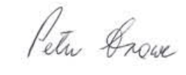
Peter Crowe
Chair
Softwoods Working Group Inc.

Murray Region Forestry Hub
ABN: 3324 1194 030
M: +61 428 609 910
E: peter.crowe2@bigpond.com

